RT5350F-OlinuXino Getting started manual v1.2
by Maarten van Druten
Version 1.2 (28-3-2017)
License: GNU General Public License v3.0

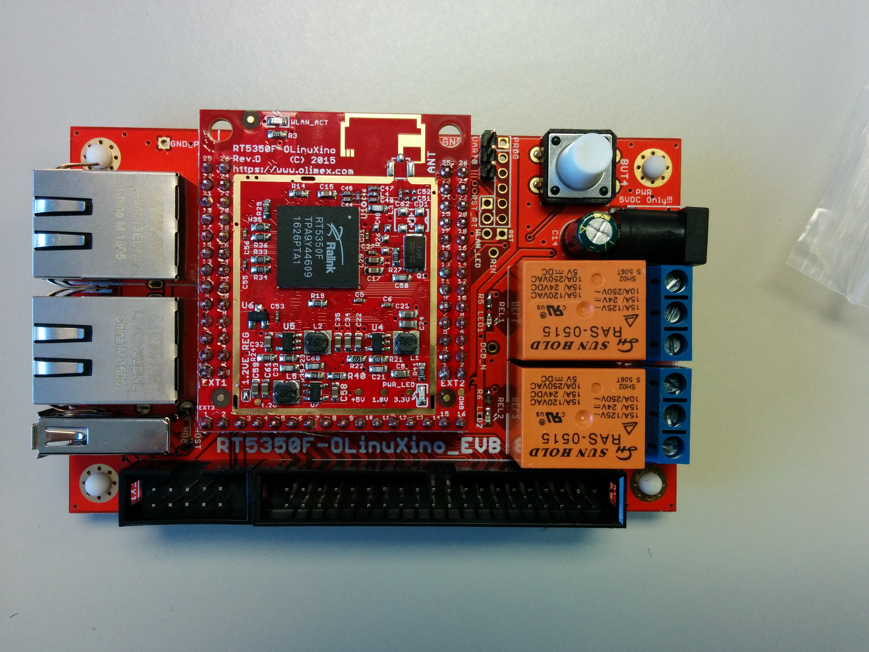

Note this board is 5V only, so use a proper power supply.
This manual is intended for starters that have no or less experience with Olimex or other development boards.

How-to connect the “USB-Serial-Cable-F” to the RT5350F-OlinuXino board?

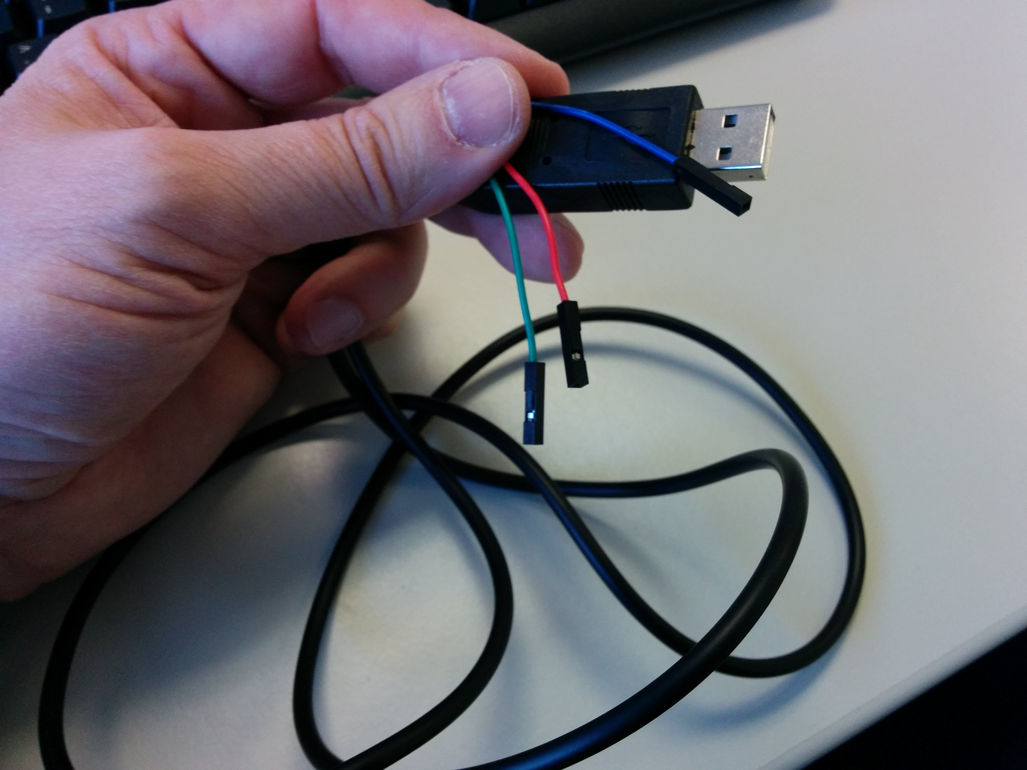

On the cable the colors are:
BLUE = GND
RED = TX (OUTPUT)
GREEN = RX (INPUT)

But they are going to connected differently onto the board!

Connecting the Olimex “USB-Serial-Cable-F” to the board:
The RX line of the cable (GREEN wire) should go to TX line of the target board,
the TX line of the cable (RED wire) should go to the RX line of the target board.
The BLUE wire should go to the target's GND line.

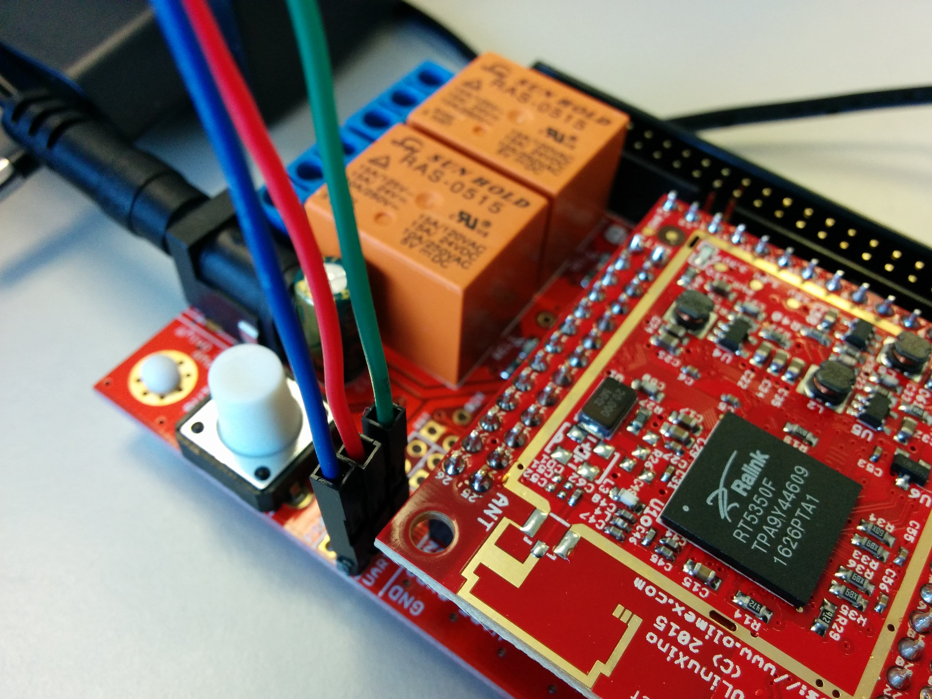

I'm going to connect the cable to a laptop that has Ubuntu 14.04 LTS OS installed

Before we can connect to the device with the USB-serial cable, we first have to install a program on Ubuntu 14.04 called “Screen”

Installation of “Screen ”

Install screen by running the following command:

sudo apt-get install screen
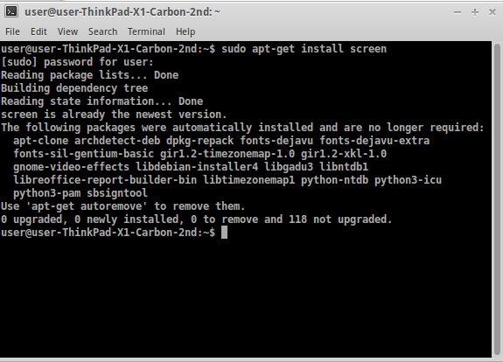

To verify that screen has been installed, type: screen -v
and you will see something similar to Screen version 4.02.01 (GNU) 28-Apr-14. You can also run which screen and it will show /usr/bin/screen.

Connect the cable to the board, open an terminal and type:

dmesg |grep USB

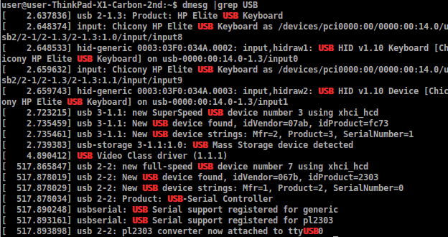
Now you can verify on which “tty” your Olimex device is connected

In the terminal you can see the connection has been made on ttyUSB0

[ 517.865847] usb 2-2: new full-speed USB device number 7 using xhci_hcd
[ 517.878019] usb 2-2: New USB device found, idVendor=067b, idProduct=2303
[ 517.878029] usb 2-2: New USB device strings: Mfr=1, Product=2, SerialNumber=0
[ 517.878034] usb 2-2: Product: USB-Serial Controller
[ 517.890248] usbserial: USB Serial support registered for generic
[ 517.893161] usbserial: USB Serial support registered for pl2303
[ 517.893898] usb 2-2: pl2303 converter now attached to ttyUSB0

Now type:

sudo screen /dev/ttyUSB0 57600

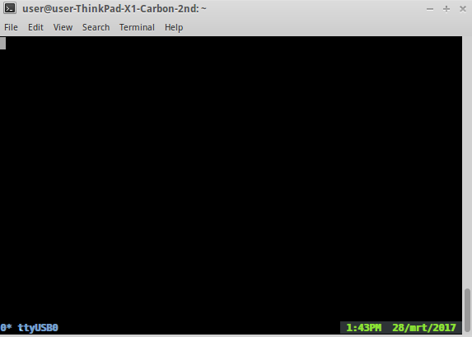

Then power on the board by plugging in the power adapter

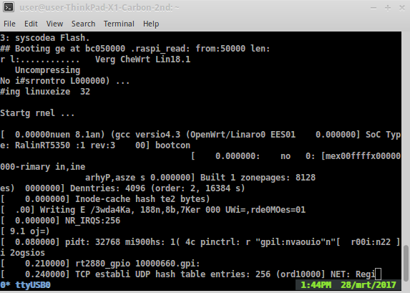

this can take some time

press enter

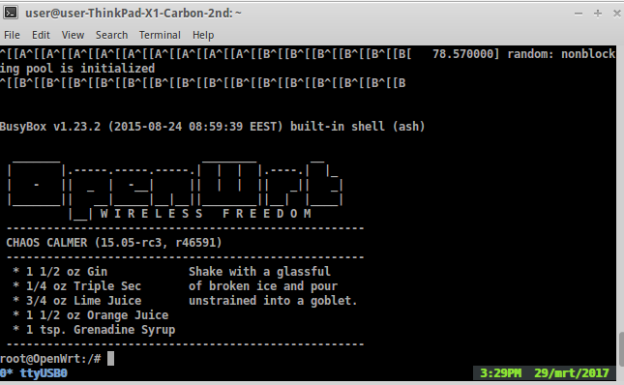

Now you can configure your Olimex RT5350F with your web browser: 192.168.1.1
First we are going to change the root password
Type: passwd

And type your new root password two times
Advise: use long passwords containing: random letters, numbers and special characters)

Tip:
Don't write down this password on any digital media, but instead write it down in your physical small personal “passwords/contacts” book.

Configuring your Olimex RT5350F with the web GUI:

Go in your web browser to the ip address of your Olimex RT5350F
In this example it is: 192.168.1.1

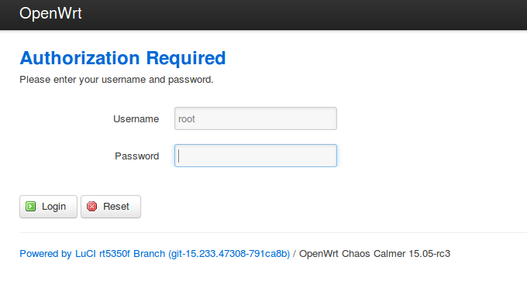

Login with your root password

Part 2 --------------------------------------------------------------------------------------------------------------

How to configure mesh networking on Open WRT
...we need still more info about what protocol and which configuration is the best suited for a globally compatible open wifi mesh network...

To manage the routing we need to install additional software:
We are going to use the “B.A.T.M.A.N” mesh protocol because of the following advantages:

- Protocol Agnostic (IPv4 / IPv6 / IPX / Apple talk...)
- Devices don't even need an IP Address.
- Clients can't roam
- Self building, healing and scaling
- Can have a gateway nominated to get out of the mesh.

Option 1: Installing the “B.A.T.M.A.N” software using the OpenWRT Web-GUI:

Login into your router with web-browser (for example: 192.168.1.1)

Go to – “System” - “Software”

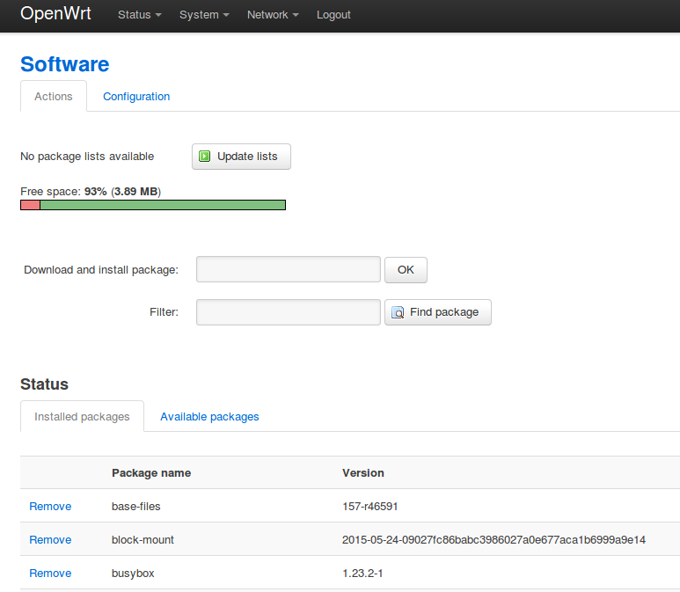

Update the list

Go to “Available packages” and select the letter “B”

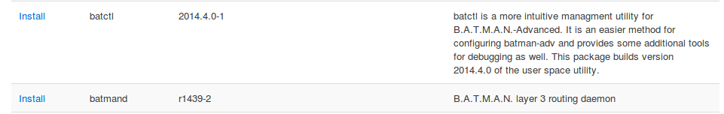

Here you select and install the B.A.T.M.A.N packages

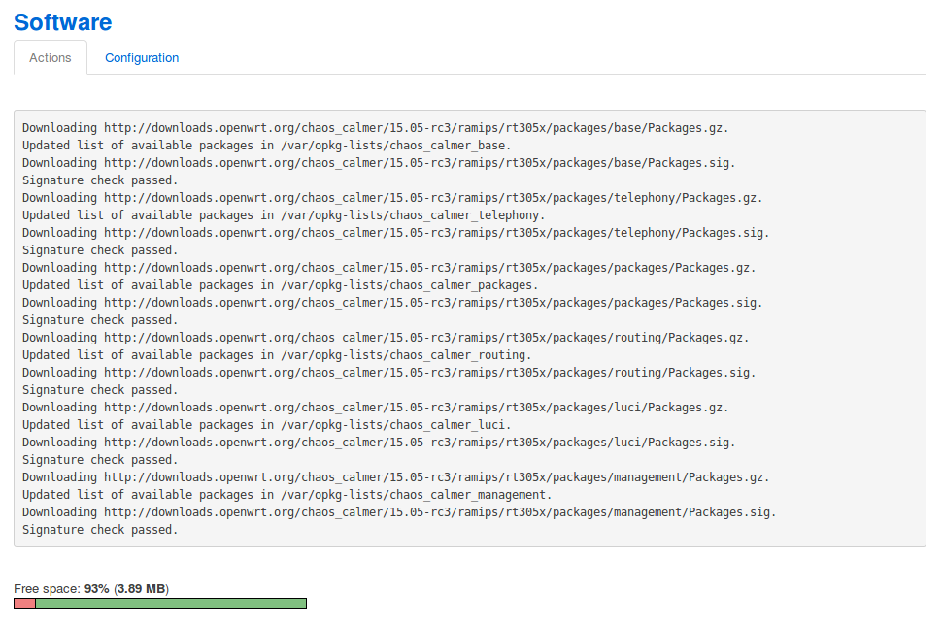

Option 2: Installing the software in a terminal:

first update the channel:
opkg update

Then install “B.A.T.M.A.N”
opkg install kmod-batman-adv

Part 3 --------------------------------------------------------------------------------------------------------------

Finding a case for the RT5350F

I found this litte foodbox that makes a perfect case for the RT5350F
This case I bought at a German shop called “Action” for 0.29 euro cents.

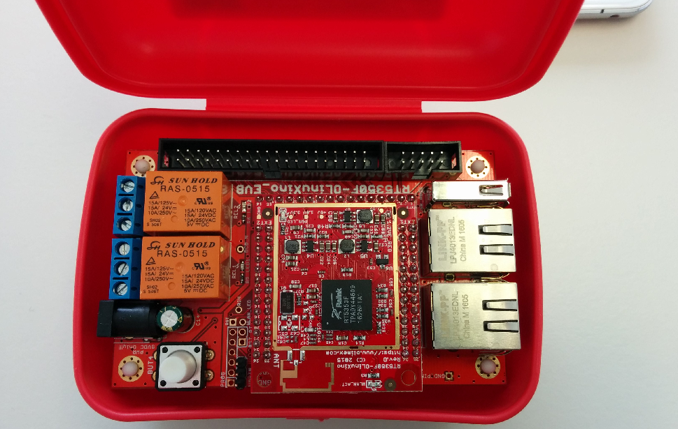

The RT5350F fits perfectly, I only had to make some holes for power and RJ45 NIC adapters
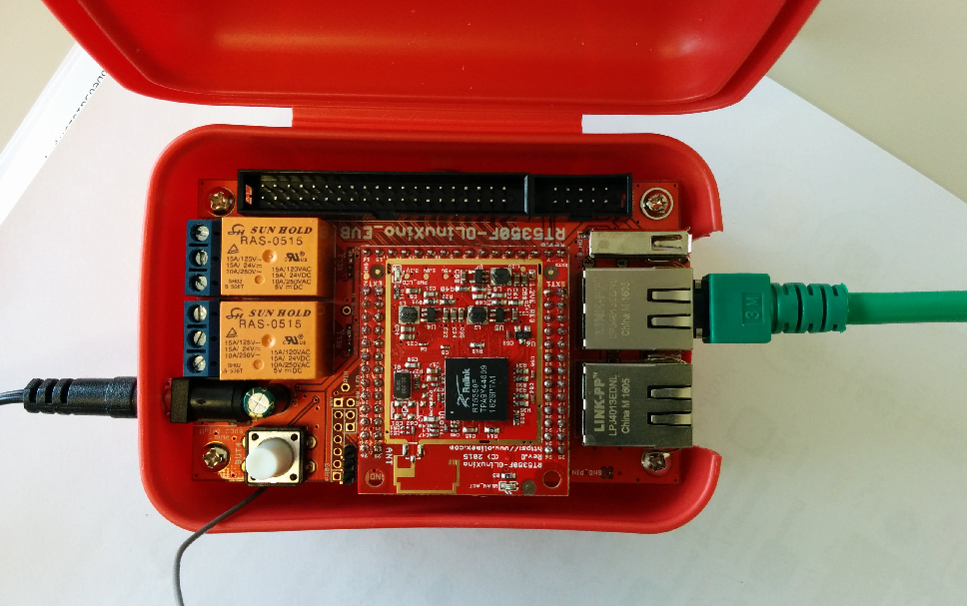
Make sure that the hole for the 5V power plug is big enough, so it will fit easily without friction
otherwise the plastic of the case could push the plug out

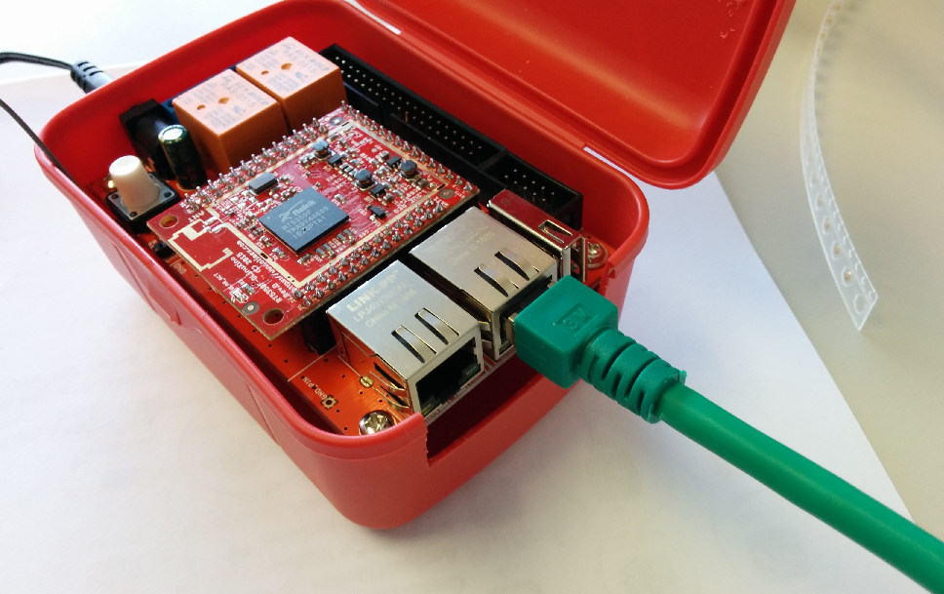

How to add and external antenna
To add an external antenna you will have to solder an ipex MHF connector on the board.
These ipex MHF connectors are very small (approx 2 mm), so you will need experience with soldering small parts.

I ordered this part:
Article number: RECE-20279-001E-01
Link: http://eu.mouser.com/ProductDetail/Taoglas/RECE-20279-001E-01/?qs=WUa1z%2fNV9%252b3mVij1vDlP0A==
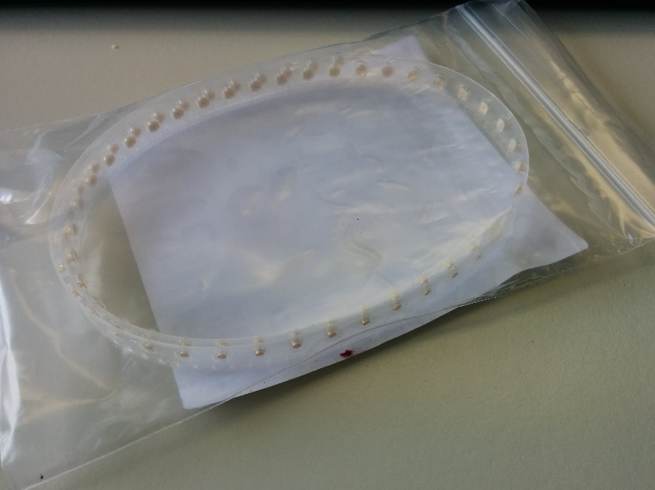
They come on a strip like this
There is a “ground contact” part (the bottom plate) that faces two sides
and there is a sideways “contact” part, that only points out to one side.

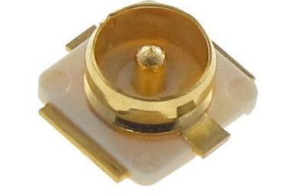

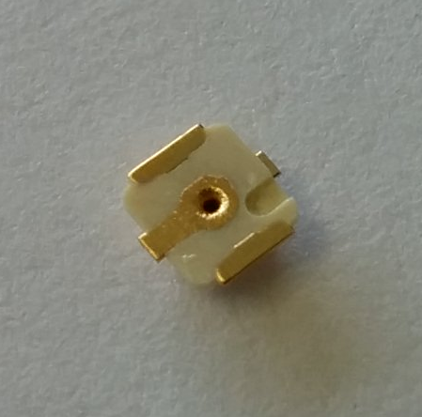

You will have to solder it, so that the “contact” side is facing to the right (see photo)
and the “ground” is facing to the left. (see photo below)

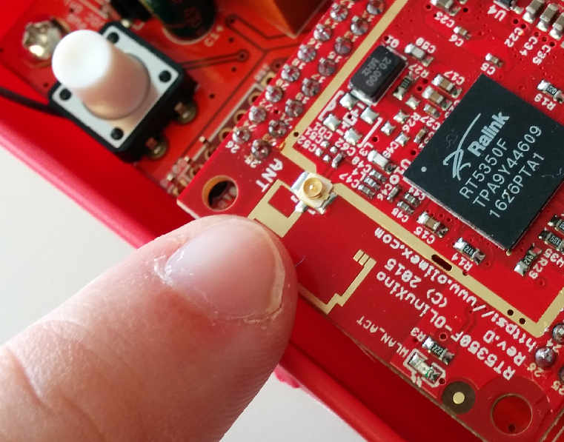
I placed the connector on the place were it has to be soldered.
So if you can see these ipex MHF connectors are very small!

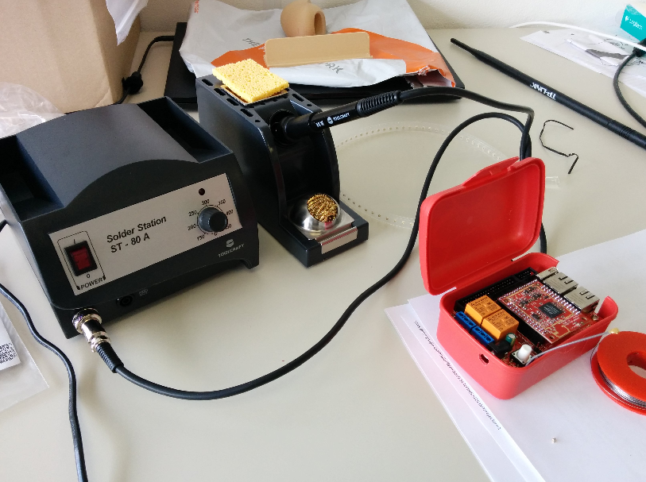
You need a soldering station with a very fine tip, and have experience with soldering small parts.

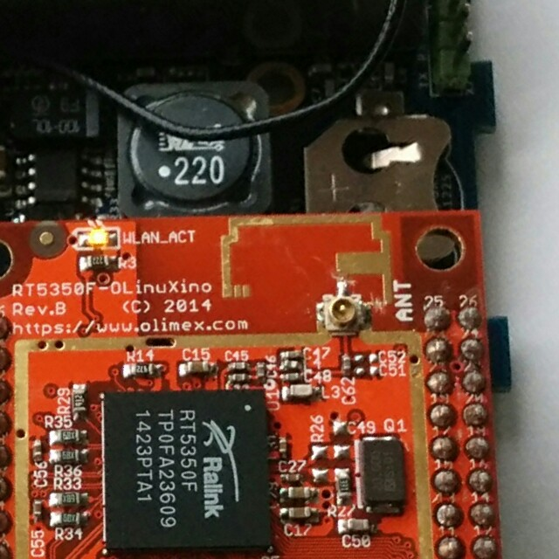

You see we have cut through the two lines from the antenna. (see arrows above)

To cut through the two lines I used the following tool that I bought by:

Adding an External antenna:

Then you have to modify the case, so that the external antenna connector can be placed.
First you have to make a hole in the case (be carefull the plastic is tough.)
Then attach the coax cable connector:
I used the following part:
COAX KABEL MIT UFL RPSMA RN-UFL-SMA6
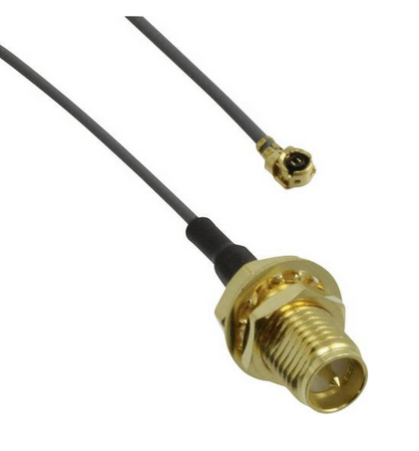
https://www.conrad.de/de/kabel-microchip-technology-rn-ufl-sma6-708879.html

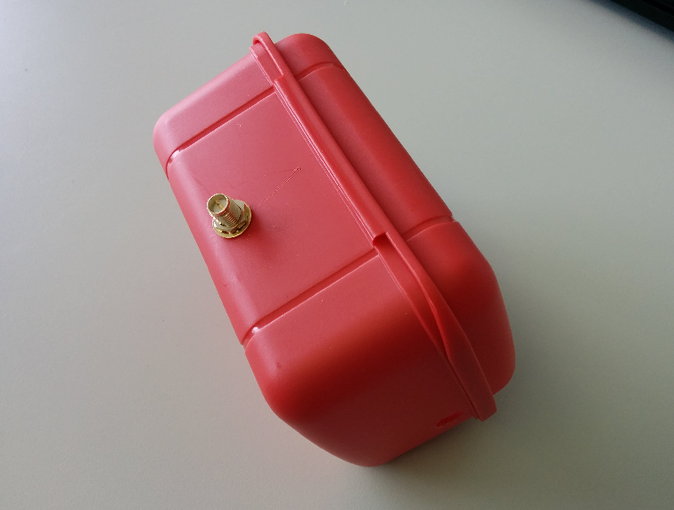
Install the coax cable connector in the case.

Then attach the external wifi antenna,

I bought the following 2.4 Ghz antenna:
Brand: TP-Link
2.4GHz 9dBi indoor
Omni-directional Antenna
Model: TL-ANT2409CL

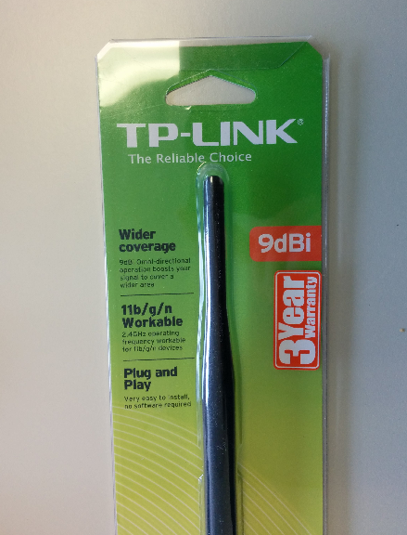

frequency Range: 2.4GHz-2.5GHz
Impedance: 50 Ohms
Gain: 9dBi
VSWR: < 2.0
Polarization: Linear
Radiation: Omni
Connector: RP-SMA Female

Note:
At my company we did some tests and we had good results with this brand,
This 9 dBi TP-Link antenna performed better than other (cheaper) brands 11 dBi antenna's.
The copper core inside this antenna seems to have a better design and quality.

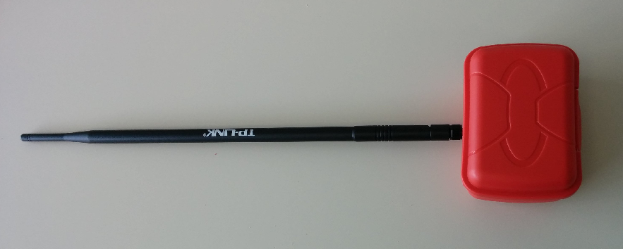
The 9dBi antenna is rather long ;-)

